AGRICULTURE PRODUCTION OPTIMIZATION ENGINE

Aryan Kushwaha Ankith Raj Vaibhav Singh

Department of Computer Science in Artificial Intelligence and Machine
learning , Chandigarh University , Mohali.

Abstract— E-agriculture is the integration of technology and digital mechanisms into agricultural processes for more efficient output. &is study provided a machine learning–aided mobile system for farmland optimization, using various inputs such as location, crop type, soil type, soil pH, and spacing. Random forest algorithm and BigML were employed to analyze and classify datasets containing crop features that generated subclasses based on random crop feature parameters. &e subclasses were further grouped into three main classes to match the crops using data from the companion crops. &e study concluded that the approach aided decision making and also assisted in the design of a mobile application using Appery.io. &is Appery.io then took in some user input parameters, thereby offering various optimization sets. It was also deduced that the system led to users’ optimization of information when implemented on their farmlands.
Keywords—Agricultural Production , Farmer income , crops , agriculture production structure optimization , foode security.
Introduction

Agriculture is vital for the development of the world. We, humans, benefit from agriculture one way or the other, which has made agriculture a key area of study. Farmers will always need information to refer to, most especially when growing crops that are not common in their land or culture and average farmer has access to crude sources of information such as TV, radio, newspapers, fellow farmers, government agricultural agencies, farm supply, and traders and there is, therefore, a need for a system that allows farmers access to relevant information.

As we all know that agriculture depends largely on the nature of soil and the climatic conditions and the nature of soil and the climatic conditions and many a times, we face unpredictable changes in climate like , non-seasonal rainfall or heat waves or fluctuations in humidity levels, etc. and all such events cause a great loss to our farmers and farming, because of which they are not able to utilize their agricultural land to it’s fullest. So to solve all such problems, I ahave build a Machine Learning Model by the virtue of which we can help farmers, optimize the agricultural production, because this predictive model will help them understand that for a particular soil and given climate condition, which crop will be best suitable for the harvest.

Machine learning is among the trending technologies; hence, there exist several technologies and systems that run on a machine learning framework . In recent times, several machine learning systems in agriculture have been tested and created. Research of several machine learning algorithms’ effectiveness in agriculture and other application domains has also been conducted and this is because machine learning is a very effective tool for efficient use of resources, prediction, and management, which are needed in agriculture. Machine learning is the ability of an electrical processing system to acquire knowledge and apply that knowledge.

The scope of this work is concerned with food crop agriculture and using machine learning to help optimize land for maximal crop yield by efficiently utilizing land resources. Crop yield relies strongly on how effectively the basic land requirements can be utilized; land here refers to topography, soil type, soil nutrients, water content, sunlight, and all such factors related to crop growth on farmable areas.

There are 7 key factors that we have taken into account which will help us in determining , exactly which crop should be grown and at what period of time, viz. Amount of Nitrogen, Phosphorous and potassium in soil , Temperature in degree celcius , Humidity, pH and rainfall in mm

In agricultural production structure optimization, uncertainties may exist in many factors (e.g., weather, temperature, marketing, resources available, soil chemistry, diseases, water, mechanical engineering, biology, economy, society, policy, and ecology) and may be presented as multiple formats (e.g., fuzzy sets, probabilities, and/or interval values) (Such uncertainties can result in interactive and dynamic complexities in terms of agricultural resources allocation over multiple contexts, and could affect the related optimization processes and the generated decision schemes. Therefore, uncertainties should be considered in developing agricultural production optimization strategies Nevertheless, few previous studies were reported on the application of inexact interval-probabilistic optimization methods for agricultural production structure optimization and evaluating the appropriateness of different policies and practices regarding the balance between producing for the market versus producing for local food security. Therefore, in response to the above challenges, an interval-probabilistic agricultural production structure optimization model (IPAPSOM) is developed in this paper. The developed IPAPSOM model will incorporate the probabilistic programming model (PPM) and the inexact interval programming model (IPM) within a general framework for better accounting for complicated interactions, trade-offs, uncertainties, and system reliabilities in agricultural production structure optimization. Then, the developed IPAPSOM model is applied to a case study of Dancheng County as a typical traditional agricultural region, in Henan Province of central China.

The purpose of this paper is to optimize agricultural production structure of major grain producing areas, such that local food security could be guaranteed, grain farmers’ welfare, food varieties could be increased, extra remuneration could be provided and farm labor could be fuller utilized. The traditional agricultural society is being transformed into a modern, industrial and urban society, and the economy is changing from a traditional planned economy to a modern market system.
METHODOLOGY
Land resources allocation is a specialized land use planning problem, in which different land resources have to be allocated to multiple users for the optimum production plan over a multi-period planning horizon. The challenge for land managers and their advisors is to formulate complex, spatially and temporally interdependent patterns of land use to achieve multiple, non-commensurable and frequently conflicting goals. Thus, this paper developed an interval-probabilistic agricultural production structure optimization model (IPAPSOM), aiming at generating a range of alternative land use plans to support the land manager in the decision making process. The IPAPSOM can effectively address uncertainties presented as interval values and probability distributions. Besides, the IPAPSOM considers not only economic factors, but also food security, resource preservation and ecological benefit constraints, which can effectively reflect various interrelations among different aspects in a mixed crop-livestock-processing system. Moreover, the IPAPSOM allows violations for capacity constraints under a range of probability levels, which are associated with trade offs between the system benefits and the constraint violation risk, such that decision alternatives can be generated through interpretation of the solutions. Also it entails the assessment of reliability for satisfying (or risk of violating) the system constraints under uncertainty. There is a range of agricultural applications based on the technique of interval programming or probabilistic programming, including scheduling replacements in sow farms (Rodríguez et al. 2009), determining the optimum production and marketing decisions on crop and examining impacts of subsidy scheme and utility function on portfolio choice in agriculture (Lien and However, few studies were reported to incorporate above two methods within a general optimization framework to adjust agricultural production structure for maximizing farmers’ interests and simultaneously ensuring national food security. Characteristics of the agricultural production structure optimization system could be summarized as follows:

(1) Multiple agricultural industry types. In order to guarantee steady economic benefit, multiple agricultural industry types should be adopted jointly in an agricultural system. Employment of systematic optimization methods for agricultural production planning would be essential for integrated reflection of significant factors components and complex characteristics.

(2) Multiple objectives. A number of objectives (e.g., eco-social benefit maximization, food security, and ecosystem service) as well as their interactions are contained in agricultural system. Competitions and interactions may exist not only in each individual objective but also between each other. For example, more allocation of farmland to economic crops will result in more system benefits but lead to more food security risk, thus demanding control of economic crops expansion. Besides, more allocation to grain crop. will be propitious to food security but will obtain less system benefits, thus requiring efforts to build deep processing of grain crops to promote the added-value of agricultural products or develop livestock breeding in response to system benefits maximization. These objectives are comparatively interdependent with a certain degree of interaction.

(3) Multiple optimization technologies. A multitude of relevant agricultural plans (e.g., crop spatial distribution pattern, land-use sustainability assessment, soil and water suitability evaluation, projection of the market price, product output and cost, supply and demand of agricultural products) are involved in such a system. Some of these plans are principally dominated by spatial optimization, which is based on GIS technology, while others are mainly realized by quantitative optimization, which is based on mathematical models (e.g., linear programming, simulation model).

(4) Complex and uncertain characteristics. The complexities may exist in making compromises between farmers’ income increase and food security guarantees. Besides, uncertainties are further complicated by a variety of imprecise information such as socio-economic and geographic conditions, resource-quality characteristics, market prices, demand projections, variable costs and the capacity. They can hardly be available as deterministic data. Thus, uncertainties may exist in multiple formats, leading to the complexities in the relevant decision-making process.

(5) Dynamic characteristics. Normally, agricultural market, production capacity and government policies of the major grain production areas are unstable and variable, which are subject to socio-economic, geographical, demographic, ecological, legislative, resource conditions, as well as spatial and/or temporal fluctuations. Reflection of such variations would be important for generating effective planning alternatives

. Materials and Methods
Materials Database/Crop Datasets. &e data that populates this database includes the plant growth parameters that were used to form the individual decision trees in the random forest. Such data include irrigation, spacing, nutrient requirements, location, temperature, and other related factors that originated from several trusted databases. &is plant growth condition database is designed to help decision making with the machine learning algorithm..
Method. In this work, machine learning applied what had been used to set parameters and embedded it into a dataset on a mobile application. &e machine learning algorithm was designed to maximize land proportion. &e dataset contains parameters of some inputs that are critical for plant growth. &e machine learning algorithm defines the relationship between these input parameters and certain internally stored prediction parameters and provides a solution for the output. &e values in the database have been converted to a range system of 0 to 1; the need for conversion to the same range is due to data incoherence; data was derived from different sources and was therefore inconsistent, thus requiring a specific conversion.

Data collection and processing
The data for agricultural production optimization engine were collected by the authors in randomly selected samples from different season of harvest lands. W e gathered detailed information on agriculture from farmers and and from the private places that the crops need which type of season to grow and temperature , humidity , pH and the components required to grow these crops. Besides, the meteorological data, land-use data, and water and soil resource data were also collected from the Data Center of the National Meteorological Bureau of China, Dancheng government, and the Institute of Geographic Science and Natural Resources, Chinese Academy of Sciences, respectively. Based on GIS technology, these data were analyzed to determine crop spatial distribution pattern, assess land use sustainability, evaluate soil and water suitability and forecast effects of meteorological factors. the yield and benefit for different crops and live stock by category from the crop-livestock-processing system. the demand forecast of the economic and technical data. Table 3 indicates the demand of nitrogen, phosphor, potassium, and agricultural water resource.
Formulation of problems
The system analysis based on mathematical methods can effectively reflect uncertain, interactive, complex and dynamic characteristics of the agricultural production planning system. Their outputs can be interpreted to generate desired planning alternatives for a number of agricultural activities, as well as the relevant policies and strategies. For major grain producing bases in China, the farmers’ interest is to maximize.
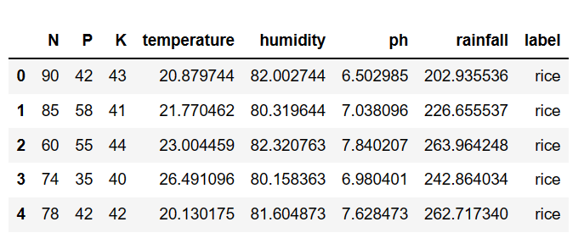

Acknowledgment 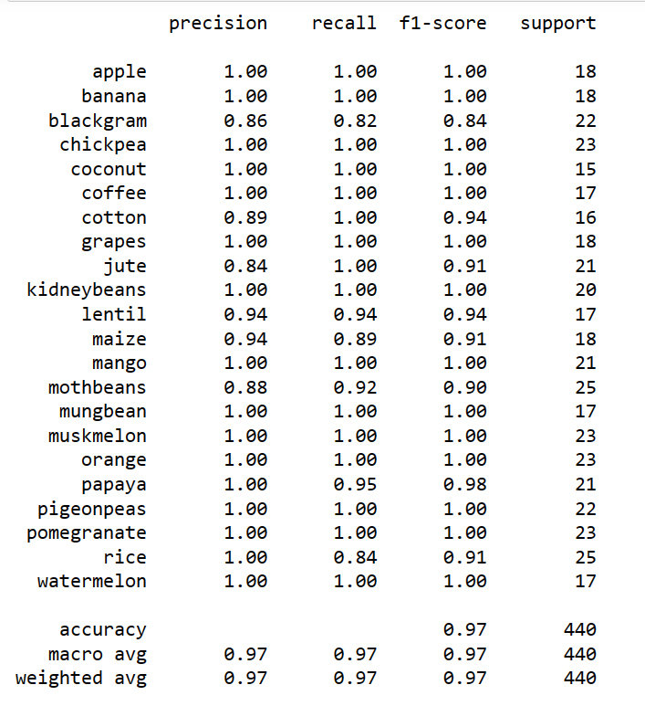

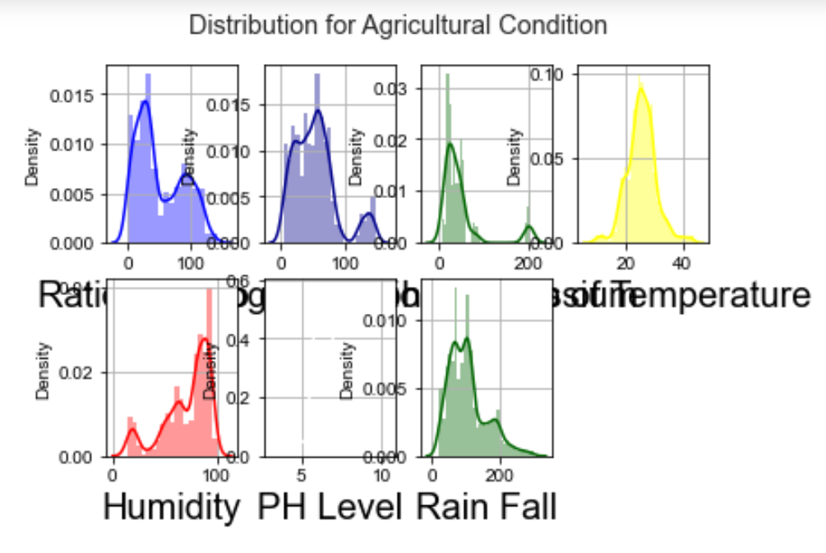 (Heading 5)

CONCLUSION

Most farmers do not have access to a central repository of relevant information that will help them make full use of and optimize their farmland. &is work provided a mobile application interface that allows farmers to access their farmland information and guarantees them the services they need instantly.

FUTURE

Work In future work, the machine learning models used to inform parameter setting in the mobile application could be developed using the machine learning algorithm embedded in the system and used to predict.

Data Availability
The data used to support the findings of this study are available from the corresponding author upon request. Ecological requirements are available in the following link: http://www.nafis.go.ke/agriculture/maize/ecological-requirements/.

Conflicts of Interest
The authors declare that they have no conflicts of interest.

REFERENCES
- C. Miller, V. N. Saroja, and C. Linder, ICT Uses for Inclusive Agricultural Value Chains, Food and agriculture organization of the united nations (FAO), Rome, Italy, 2013.
- K. Liakos, P. Busato, D. Moshou, S. Pearson, and D. Bochtis, “Machine learning in agriculture: a review,” Sensors, vol. 18, no. 8, p. 2674, 2018.View at: Publisher Site | Google Scholar
- P. Priya, U. Muthaiah, and M. Balamurugan, “Predicting yield of the crop using machine learning algorithm,” International Journal of Engineering Sciences & Research Technology, vol. 7, pp. 1–7, 2018.View at: Google Scholar
- J. H. Jeong, J. P. Resop, N. D. Mueller et al., “Random forests for global and regional crop yield predictions,” PLoS One, vol. 11, no. 6, Article ID e0156571, 2016.View at: Publisher Site | Google Scholar
- D. Ming, T. Zhou, M. Wang, and T. Tan, “Land cover classification using random forest with genetic algorithm-based parameter optimization,” Journal of Applied Remote Sensing, vol. 10, Article ID 35021, 2016, http://remotesensing.spiedigitallibrary.org/.View at: Google Scholar
- I. Nitze, U. Schulthess, and H. Asche, “Comparison of machine learning algorithms random forest artificial neural network and support vector machine to maximum likelihood for supervised crop yield classification,” in Proceedings of the 4th GEOBIA, pp. 35–40, Salzburg Austria, May 2012.View at: Google Scholar
- X. Chen and P. Cournede, “Model-driven and data-driven approaches for crop yield prediction: analysis and comparison,” International Scholarly and Scientific Research & Innovation, vol. 11, no. 7, pp. 334–342, 2017.View at: Google Scholar
- P. Mitra, A. Mukherjee, and A. Chandra, “Machine learning for prediction of crop yield: a case study on rain-fed area rice yield from West Bengal, India,” in Proceedings of the DSANRM2017: Workshop on Data Science for Agriculture and Natural Resource Management, International Institute of Information Technology (IIIT, Hyderabad), December 2017.View at: Google Scholar

IEEE conference templates contain guidance text for composing and formatting conference papers. Please ensure that all template text is removed from your conference paper prior to submission to the conference. Failure to remove template text from your paper may result in your paper not being published.

We suggest that you use a text box to insert a graphic (which is ideally a 300 dpi TIFF or EPS file, with all fonts embedded) because, in an MSW document, this method is somewhat more stable than directly inserting a picture.
To have non-visible rules on your frame, use the MSWord “Format” pull-down menu, select Text Box > Colors and Lines to choose No Fill and No Line.

